**Object Detection**

**Latest Submission Grade 100%**

**1.**

Question 1

Check all the techniques that can be used to improve the accuracy of detecting objects and encapsulating them entirely within a single bounding box.

**1 / 1 point**



Increase the size of the bounding box until the object fits entirely in it.

**Correct**

Correct! That is one of the simplest techniques.



Use Selective Search technique

**Correct**

Correct! It is an advanced technique, and faster than a naive approach.



Scale down the image and then detect the object within it using the bounding box

**2.**

Question 2

Check all that are true for *Selective Search*.

**1 / 1 point**



It tries to identify larger objects by grouping together initially identified smaller objects.

**Correct**

Correct!



Image segmentation is used in this technique

**Correct**

Correct! It is used to identify smaller objects.



The biggest bounding box detected of the smaller objects in the end becomes the final bounding box around the identified object.

**3.**

Question 3

The technique of selecting the best bounding box based on the highest intersection over union (IOU) between the true label and several predicted bounding boxes is called non-maximum ____________ (NMS). (Hint: it is a one word answer)

**1 / 1 point**

suppression

**Correct**

Correct!

**4.**

Question 4

Consider the following image, according to the NMS technique which coloured bounding box will be eventually selected as the best bounding box around the football?

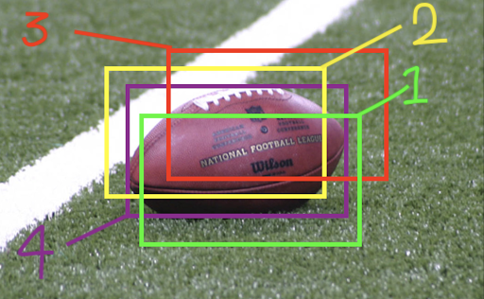

**1 / 1 point**



Purple (# 4)



Green (# 1)



Red (# 3)



Yellow (# 2)

**Correct**

Correct! As this bounding box encapsulates the maximum area of the object.

**5.**

Question 5

One of the differences between R-CNN and Fast R-CNN is that, *Fast R-CNN proposes regions of interest to the input image (generates), whereas in R-CNN regions of interest are expected to be an input (as opposed to generating them) to the model.*

**1 / 1 point**



True



False

**Correct**

Correct! R-CNN generates regions of interest to the input image, whereas in Fast R-CNN regions of interest are an input (as opposed to generating them).

**6.**

Question 6

Consider the following code and check all that are true.

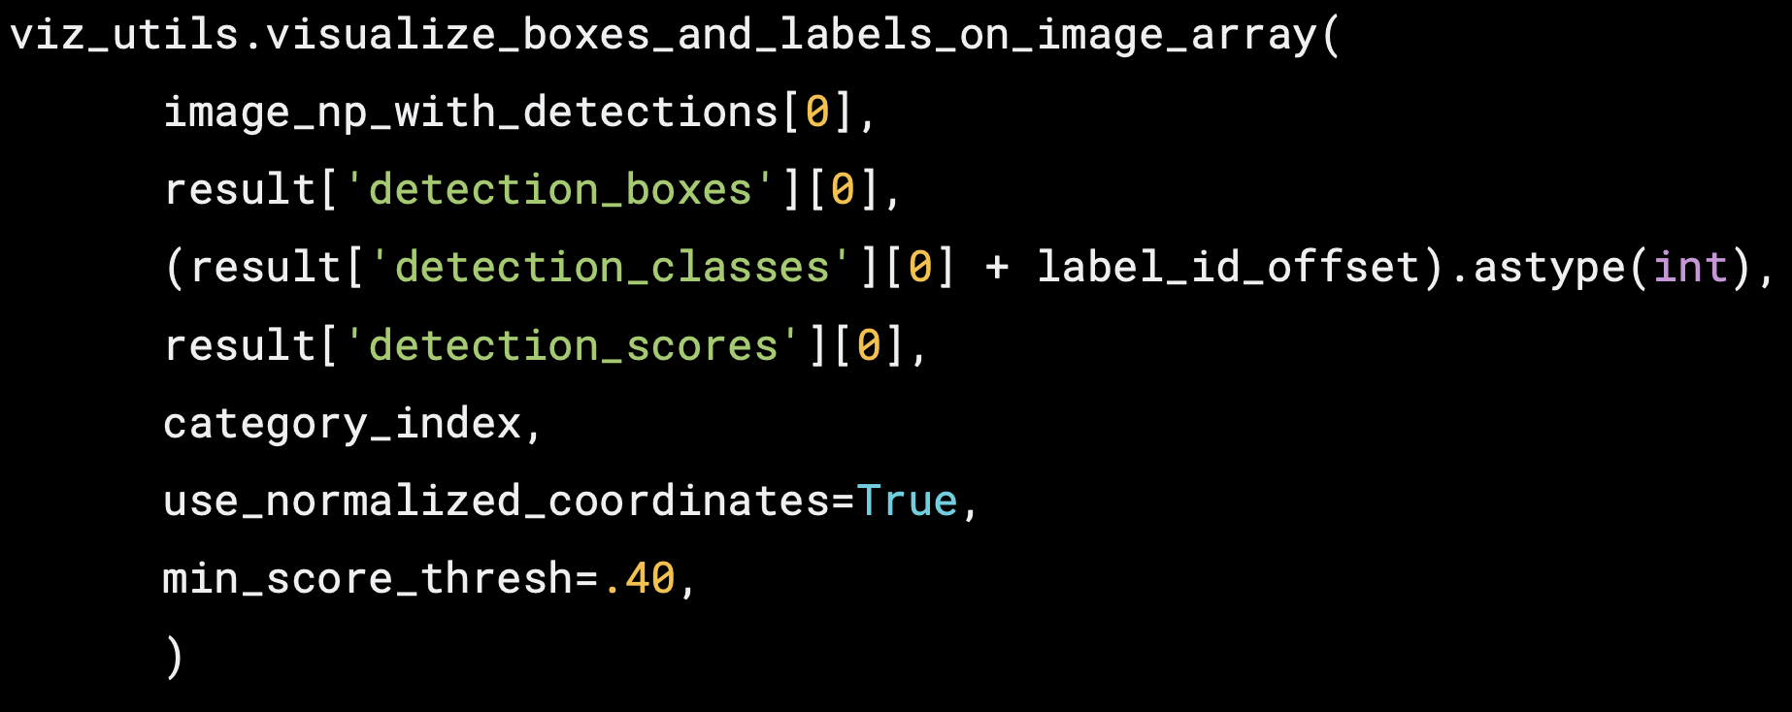

**1 / 1 point**



*min_score_thresh*is used to leave out object labels and their bounding boxes if their score falls below the set threshold.

**Correct**

Correct!



*image_np_with_detections[0]* is a numpy array containing the image, and 0 index shows there are multiple input images being passed to this function.



*label_id_offset*is an adjustment in case the ‘detection classes’ starting index and actual starting index have an offset between them.

**Correct**

Correct!



Setting *use_normalized_coordinates=True* indicates that your bounding box coordinates are not normalized, so you want them to be normalized.

**7.**

Question 7

The following code initializes a model and restores pre-trained weights, *detection_model,* using the .config file method

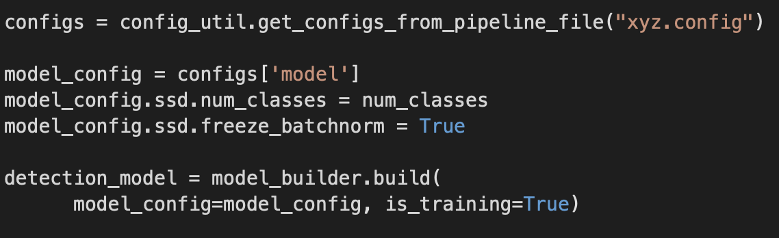

**1 / 1 point**



True



False

**Correct**

Correct! The code here only initializes a new model architecture with “empty” weights and does not restore pre-trained weights.

**8.**

Question 8

Which of the following is the correct syntax to print a list of your trainable variables in a model ?

**1 / 1 point**



*for varName in myModel.Variables:*

*print(varName.name)*



*for varName in myModel.trainableVariables:*

*print(varName.name)*



*for varName in myModel.trainables:*

*print(varName.name)*



*for varName in myModel.trainable_variables:*

*print(varName.name)*

**Correct**

Correct!